A Seat at the Table – IT Leadership in the Age of Agility – Part 3

By Mark Schwartz

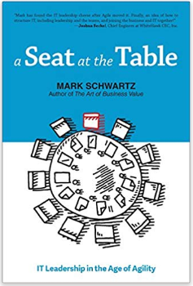“ Courage, I say, is the value most needed by Agile IT leaders.”  
 – **Mark Schwartz**

# Last Time in Part 2

**Enterprise Architecture:** The job of IT leaders is not to execute projects on behalf of the business; it is to steward the asset that is the total of all of the enterprise’s IT capabilities—an asset that has functional capabilities (how it is used today) but also latent capabilities (how it will support future agility and how it will offer options in the future).

**Build Versus Buy:** In a world where IT capabilities were delivered as a single “product” at the end of a project, a “product” that then only required a bit of maintenance now and then, the economics of IT delivery often favored buying a product off the shelf. But when we view IT capabilities as being in a continuous state of transformation, when we see them as tightly integrated into an EA, and when we realize that the costs and risks of custom development have been radically reduced, the economics often now favor custom development.

**Governance and Oversight:** Governance has traditionally been viewed as a filter; a way of allocating scarce IT resources among many competing projects. But in a world where IT is integral to strategy, it makes more sense to begin from strategic objectives and produce investment themes that accomplish those objectives. When combined with Agile and Lean practices, this approach can focus IT planning, reduce risk, eliminate waste, and provide a supportive environment for teams engaged in creating value.

If you missed last month, you can find the handout for Part 2 on the Agile4Defense GitHub page at: <https://git.io/JeaO2>

# Risk

*The presence of uncertainty is the simple reason why Agile approaches work better than plan-driven approaches—it is also the reason why a good IT leader will often have to make “wrong” decisions. An IT leader adds business value by adopting an intelligent attitude toward risk.*

# Quality

*It is difficult for IT to gain a seat at the table when IT is always failing, but on the other hand, an IT leader who is reacting to statistical noise—failures that he or she has already chosen to accept—is destroying business value. An IT leader must have the necessary technical skills, make impeccable decisions under uncertainty, and then have the courage to face the consequences.*

# Shadow IT

*Agile ways of working support a community approach to IT, where IT leaders achieve their objectives by mobilizing the skills and passions of a broad community and encourage the members of that community to work together across organizational silos in a way that values skills and contributions.*

# The CIO’s Place at the Table

*IT leadership runs the business along with the others who run the business. The seat at the table is earned by being at the table.*

# Feedback

As we've come to learn on our agile journey, short cycle times and rapid feedback are the lifeblood of Lean and Agile software development practices.

After the Meetup, I would highly value hearing what those that attended the table have to say. Some things I would be particularly interested in learning about are:

* How did I do as a presenter? Is there something I could do better next time?
* How were the handouts? Were they useful, something you can take back with you to work and share with others?
* What part of Mark's book really jumped out at you as particularly insightful?
* What do you think of the Agile for Defense Meetup group as a whole? Do you like the format? Are there other formats you have seen at other Meetup groups that might be worth trying?

On the Agile for Defense Facebook group, I created a post where you can post your feedback as comments on the post. The URL to that post is:

<https://www.facebook.com/groups/AgileForDefense/permalink/2557027747901552/>

The group is private so the first time you visit you likely have to wait for an admin to approve your request to join but don’t let that deter you! We value your feedback and we need it to learn and do better. Let us hear your thoughts!

# About the Author

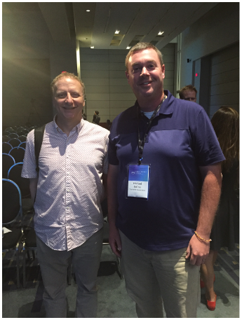Mark Schwartz is an Enterprise Strategist at Amazon Web Services and the author of The Art of Business Value and A Seat at the Table: IT Leadership in the Age of Agility. Before joining AWS he was the CIO of US Citizenship and Immigration Service (part of the Department of Homeland Security), CIO of Intrax, and CEO of Auctiva. He has an MBA from Wharton, a BS in Computer Science from Yale, and an MA in Philosophy from Yale.

Mark and Mike first met at the 2019 AWS Public Sector Summit in Washington, DC. They’ve been best friends ever since.

# Fork Me on GitHub

Did you know Agile for Defense has a page on GitHub where we post many of our table topics?

You can find this one and others at: <https://github.com/Agile4Defense/AgileForDefense>

You can download this topic directly at: <https://git.io/Jejqb>